***PAAREES PERFUMES***

***CALVIN KLIEN***

***FOR WOMEN***

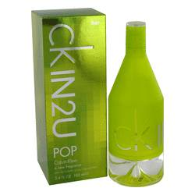

# 

***CK IN 2U POP***

## *Description:*

Ck In 2U Pop by Calvin Klein Perfume. A limited edition, this is a chypre-fruity fragrance for her. Perfect for summer and casual wear, notes include includes tropical accords of papaya, lime bark, plum blossom, vanilla and woody notes.